28.59: The current in the wires is The currents in the wires are in opposite directions, so the wires repel. The force each wire exerts on the other is
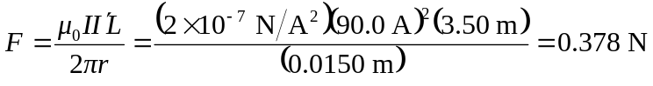

To hold the wires at rest, each spring exerts a force of 0.189 N on each wire.

